Alumnos: Costas Daniela (37992004)

Lambrech Federico (35978477)

________________________________________________________________________

Hello Federico!

Can you help me decide?

I want to buy a flash drive. I'm in between these two options, but I don't understand anything about the technical specifications. The Imation flash drive is cheaper, but it’s made of plastic, while the Corsair's is more expensive because it’s aluminum.

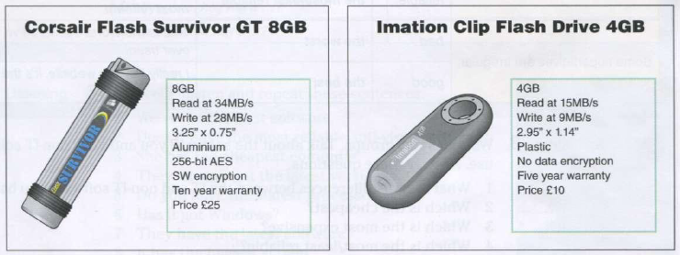

What do you think? Which one is better?

______________________

Hello Daniela!

Yes, I can help you with that! It depends on the purpose you'll give it.

For example, if you need it to save pictures, the first one is a better option, because that one has larger storage capacity. But, if you need it for downloading Word archives, PDFs or similar files, I recommend the second one, because in that case a flash drive with less storage will be useful and cheaper.

Can you tell me what would you use it for?

______________________

Hi again!

Well I want it to save my vacation photos. I guess the Corsair will be more efficient, but It costs $25, I have to start saving money!

Thanks for the help.

See you soon!

_______________________

You're welcome Daniela!

Any time you want, greetings!